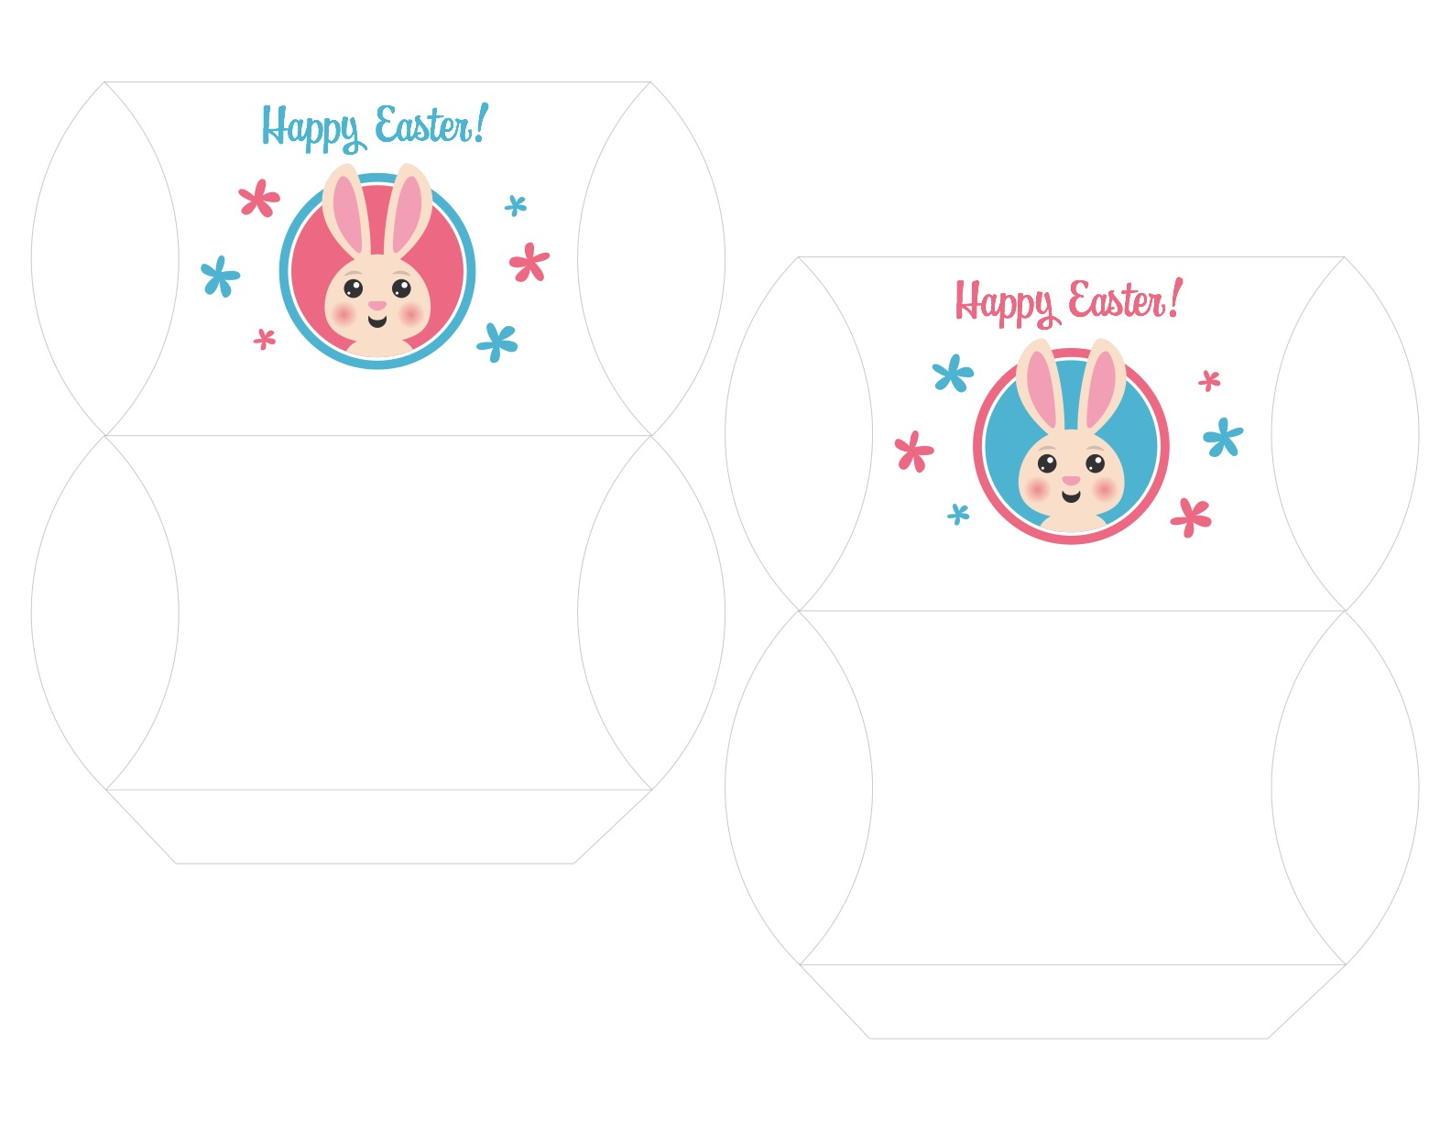­­

1. Customize the names by clicking within the text box.
2. Print template on white or colored cardstock of your choosing.
3. Cut out along the outer gray lines.
4. Score and fold along the inner gray lines.
5. Glue the flap.
6. Fill your finished piece with Easter candy and enjoy!

**Name Here**

**Name Here**