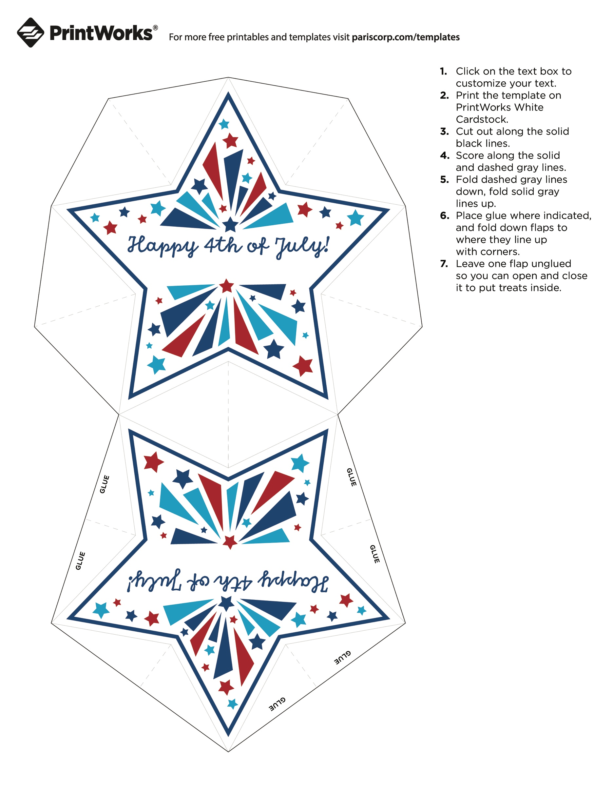

**Love, the Smiths**

**Love, the Smiths**