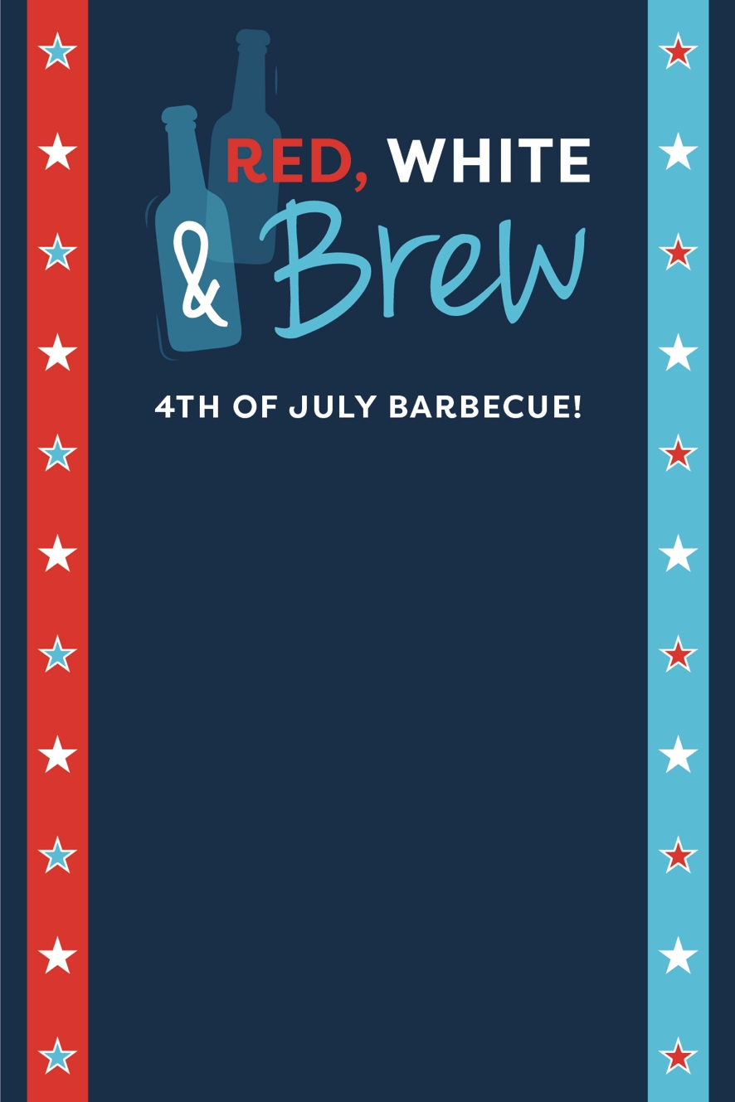

**Thursday, July 4th**

**5 PM at Jake & Amy’s**

Bring your favorite outdoor games and drinks to share!

RSVP to Amy by June 23

**Instructions**

*Delete this page before printing*

Click inside the text boxes to add a personalized message.

For best results when printing, make sure paper size is set to 4x6 inch borderless.

RSVP to Amy by June 23