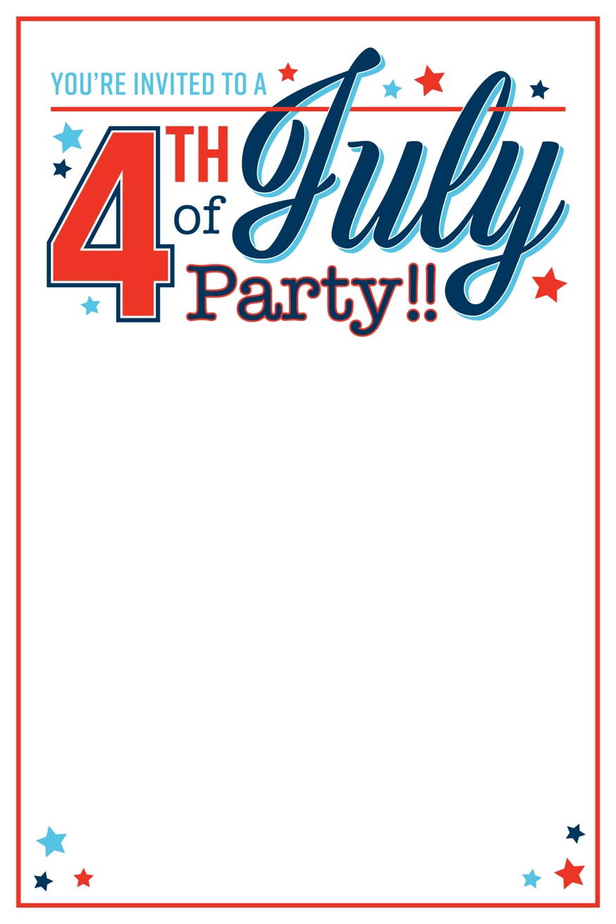

**Thursday, July 4th**

**5 PM at Sam & Libby’s**

1234 Patriotic Way

Philadelphia, PA

**Bring your favorite outdoor games and a dessert to share!**

Please RSVP to Libby by June 23

856-000-1776

**Instructions**

*Delete this page before printing*

Click inside the text boxes to add a personalized message.

For best results when printing, make sure paper size is set to 4x6 inch borderless.

RSVP to Amy by June 23